Track (AM/SM/AF/AI/BD/DM/HR/ID/MT/PR/SD/SE/EG/TD/TL/RD): Insert appropriate track acronym here.

A Simple Analytical Model of Laser Bending Process {Times New Roman, 14 points}
Author One ¹, Author Two^{1*} and Author Three² {Times New Roman, 12 points}
¹Department of [Name 1], Indian Institute of Technology Guwahati, Assam, India. {Times New Roman, 12 points}
²Department of [Name 2], Name of Institute, Location, India. {Times New Roman, 12 points}
Email of all authors in sequence. {Times New Roman, 12 points}
*Corresponding author, Email: {Times New Roman, 12 points}

{Times New Roman, 11 points}
Laser bending is a process of bending a sheet by the irradiation of laser beam on the surface of the sheet [1]. It is a thermo-mechanical process which is suitable for rapid prototyping and deforming the low ductility materials. This process has several potential applications in aerospace, shipbuilding, microelectronics, automotive industries, etc. it is a rapid, flexible and low-cost metal forming process that can improve the competitiveness of these industries. This process also offers a great flexibility as a lot of other applications (such as soldering, brazing and hardening) can be performed by means of the same apparatus. Several theoretical and experimental papers have been published in this area with more research focused on straight line bending by laser beam. The ultimate goal of these works is to understand the physics of the process and to produce various models for the prediction of bend angle. A brief review of these works, as well as, the different methods used for the analysis is presented in the paper. Based on these, in the present paper, a finite element analysis is carried out using ABAQUS package to predict the temperature distribution and the bending angle of a specific steel sheet material, and the results compared with a simple analytical model developed by the authors. It is ascertained from the experimental results available in the literature that the proposed theoretical model provides reasonably good prediction of the bend angle. It is also shown that the developed model can be used for the quick estimation of yield stress of the material during laser bending process.
The results from the ABAQUS simulation and the theoretical models show that
- The bend angle decreases as the yield stress of the plate material increases beyond the critical value of maximum thermal stress resulting from the heat source from the laser beam. This is to be expected as the plastic deformation through the thickness for harder materials decreases,
- The ABAQUS results presented in Figure 1 show that there is a time lag between the peak temperatures at the top and the bottom of the plate (of around 165 ºC and 115 ºC, respectively), and the maximum bend angle (at around 13 sec). This time lag is around 10 seconds,
- The temperature curve shows an exponential decay with time, and
- Bend angle results presented in Table 1 show a comparison between the theoretical model developed in the present work with some of the already published experimental results. A good agreement between the two models can be observed.
More results will be presented in the full length paper.
References {Times New Roman, 9 points}
Dixit, U.S., Joshi, S.N. and Kumar, V.H. (2012), Micro-bending with laser, in Micromanufacturing Processes, edited by V.K.Jain, CRC Press, Boca Raton, Florida.
Mishra, A. and Dixit, U.S. (2013), Determination of thermal diffusivity of the material, absorptivity of the material and laser beam radius during laser forming by inverse heat transfer, Journal of Machining and Forming Technology, Vol. 5, pp. 208−226.
Eideh, A. and Dixit, U.S. (2013), A Robust and Efficient Inverse Method for Determining the Thermal Parameters during Laser Forming, In: Proceedings of the National Conference NCRAME 2013 held at NERIST, Nirjuli, November 8-9, 2013.
Note to authors: This is only a sample abstract. Use your own judgement to bring the content in maximum two pages. Figures and tables can be inserted just after the text; they can continue even from the first page.

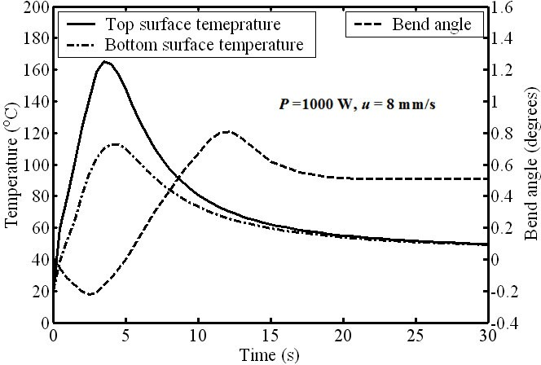

Figure 1 Variation of top and bottom temperatures, and the bend angle during heating and cooling phases

Table 1 Comparison between present model and experimental results [2, 3]
Power (W) | Scan velocity | Expt. bend ang. | Prsnt. bend ang. | % Deviation
800 | 40 | 0.41 | 0.463 | 12.93
1000 | 50 | 0.47 | 0.542 | 15.32
1300 | 65 | 0.49 | 0.58 | 18.37
550 | 15 | 1.54 | 1.72 | 11.68
550 | 30 | 0.94 | 1.02 | 8.51
550 | 40 | 0.83 | 0.77 | 7.23
550 | 50 | 0.5 | 0.61 | 22

