Manuscript Title

First Author1*(ORCID), Second Author1(ORCID), and Third Author2(ORCID)

'Affiliation, Town/City, Country  
2Affiliation, Town/City, Country  
3Affiliation, Town/City, Country  
[1abc@yahoo.com](mailto:1abc@yahoo.com)  
[2abc@yahoo.com](mailto:2abc@yahoo.com)  
[3abc@yahoo.com](mailto:3abc@yahoo.com)

Abstract. The abstract should summarize the contents of the manuscript and  
should contain up to 250 words.

Keywords: Please list your keywords here. They should be separated by mid  
dots, if possible. The first letter of each keyword should be capitalized.

1. Introduction

This document contains the guidelines for the preparation of proceedings papers.  
Instead of simply listing headings of different levels it is recommended to let every  
heading be followed by at least a short passage of text. Please note that the first line of  
text that follows a heading is not indented, whereas the first lines of all subsequent  
paragraphs are.

1.1 Subsection sample

Only the first two levels of section headings should be numbered, as shown in Table 1.  
The respective font sizes are also given in Table 1. Kindly refrain from using "0" when  
numbering your section headings.

Sample Heading (Third Level). Two levels of headings should be numbered. Lower  
level headings shall remain unnumbered; they are formatted as run-in headings.

Sample Heading (Forth Level). The manuscript should contain no more than four levels  
of headings.

Table 1. Font sizes of headings. Table captions should always be positioned above the tables.

|  |  |  |
| --- | --- | --- |
| Heading level | Example | Font size and style |
| Title (centered) | Lecture Notes | 14 point, bold |
| 1st-level heading | 1 Introduction | 12 point, bold |
| 2nd-level heading | 2.1 Printing Area | 10 point, bold |
| 3rd-level heading | Run-in Heading in Bold. Text follows | 10 point, bold |
| 4th-level heading | Lowest Level Heading. Text follows | 10 point, italic |

The equations or formulas are centered and set on a separate line. All the  
equations should be numbered for reference. The numbers should be consecutive within  
the contribution, with numbers are enclosed in parentheses and set on the right margin.  
For example,

x + y = z, (1)

where x is variable 1, y is variable 2 and z is variable 3. The figures or illustrations should  
be clear. Figure captions should begin with the term Fig. in bold type, followed by the  
figure number, also in bold type. Captions with figure numbers must be placed after their  
associated figures, as shown in Fig. 1. Captions are set in 9-point type.

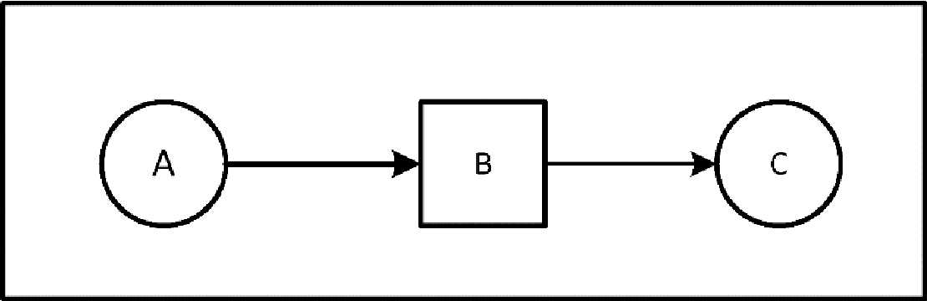

Fig. 1. A figure caption is always placed below the illustration. Short captions are centered, while long ones are justified.

For citations of references, it is preferred to use square brackets and consecutive  
numbers. Citations using labels or the author/year convention are also acceptable. The  
following bibliography provides a sample reference list with entries for journal articles  
[1], an LNCS chapter [2], a book [3], proceedings without editors [4], as well as a URL  
[5].

Acknowledgments. This should always be a run-in heading and not a section or sub-  
section heading. There should not be any number assigned to acknowledgements. The  
acknowledgments may include reference to grants or support received in relation to the  
work presented in the paper.

References

1. Author, F.: Article title. Journal 2(5), 99-110 (2016).
2. Author, F., Author, S.: Title of a proceedings paper. In: Editor, F., Editor, S. (eds.)  
   CONFERENCE 2016, LNCS, vol. 9999, pp. 1-13. Schfatz, Heidelberg (2016).
3. Author, F., Author, S., Author, T.: Book title. 2nd edn. Publisher, Location (1999).
4. Author, F.: Contribution title. In: 9th International Proceedings on Proceedings, pp. 1-2.  
   Publisher, Location (2010).
5. LNCS Homepage, <http://www.xyz.com/lncs>, last accessed 2022/03/02

Please Submit the Manuscript as per the suggestion of the Track Coordinators