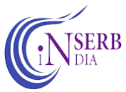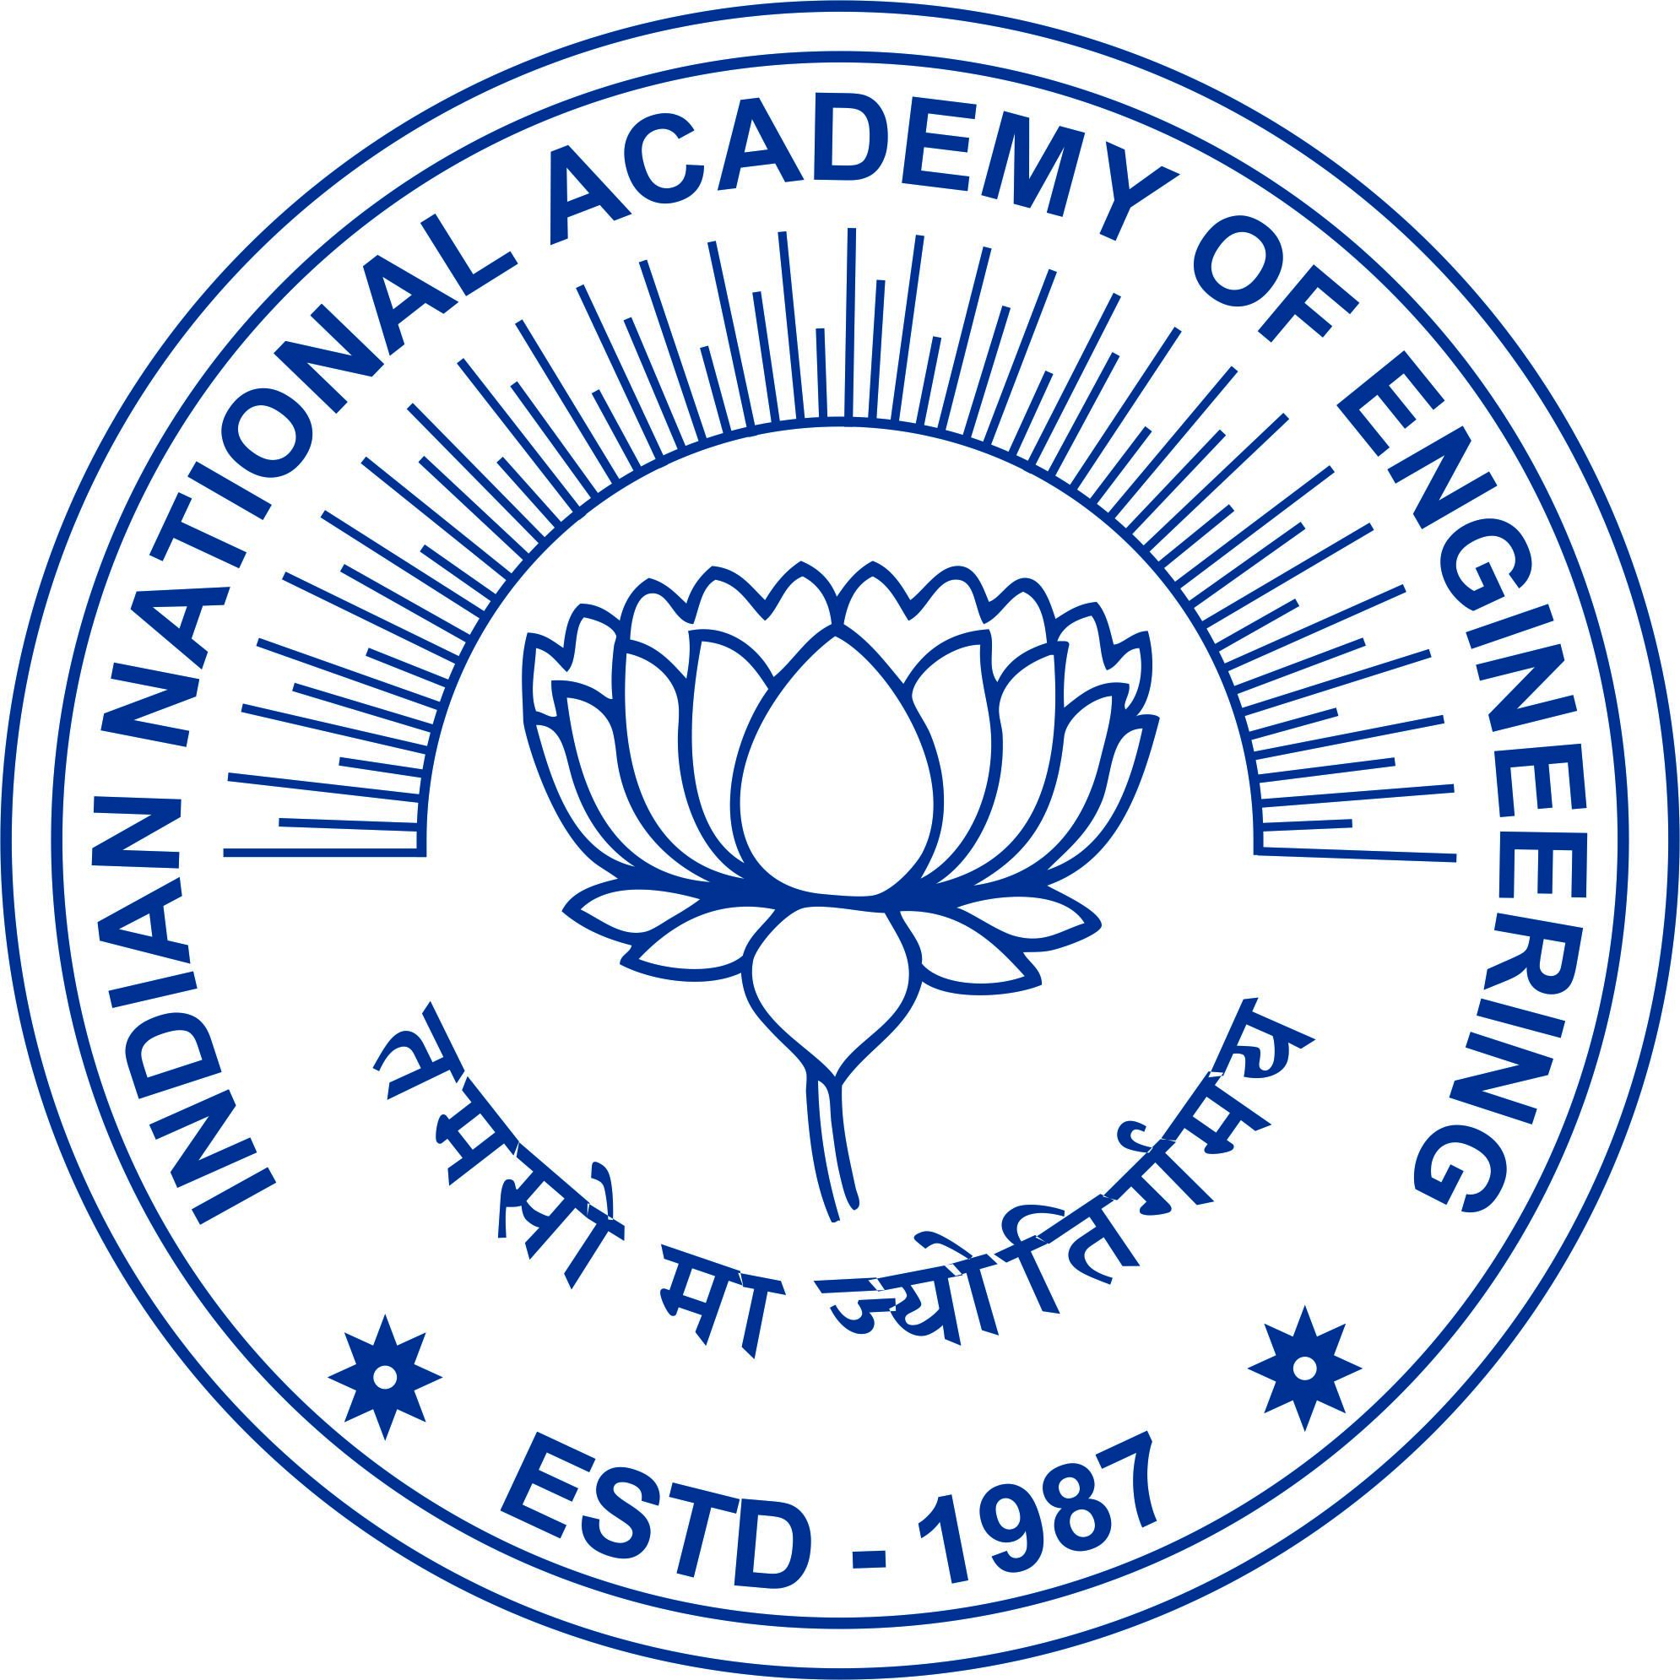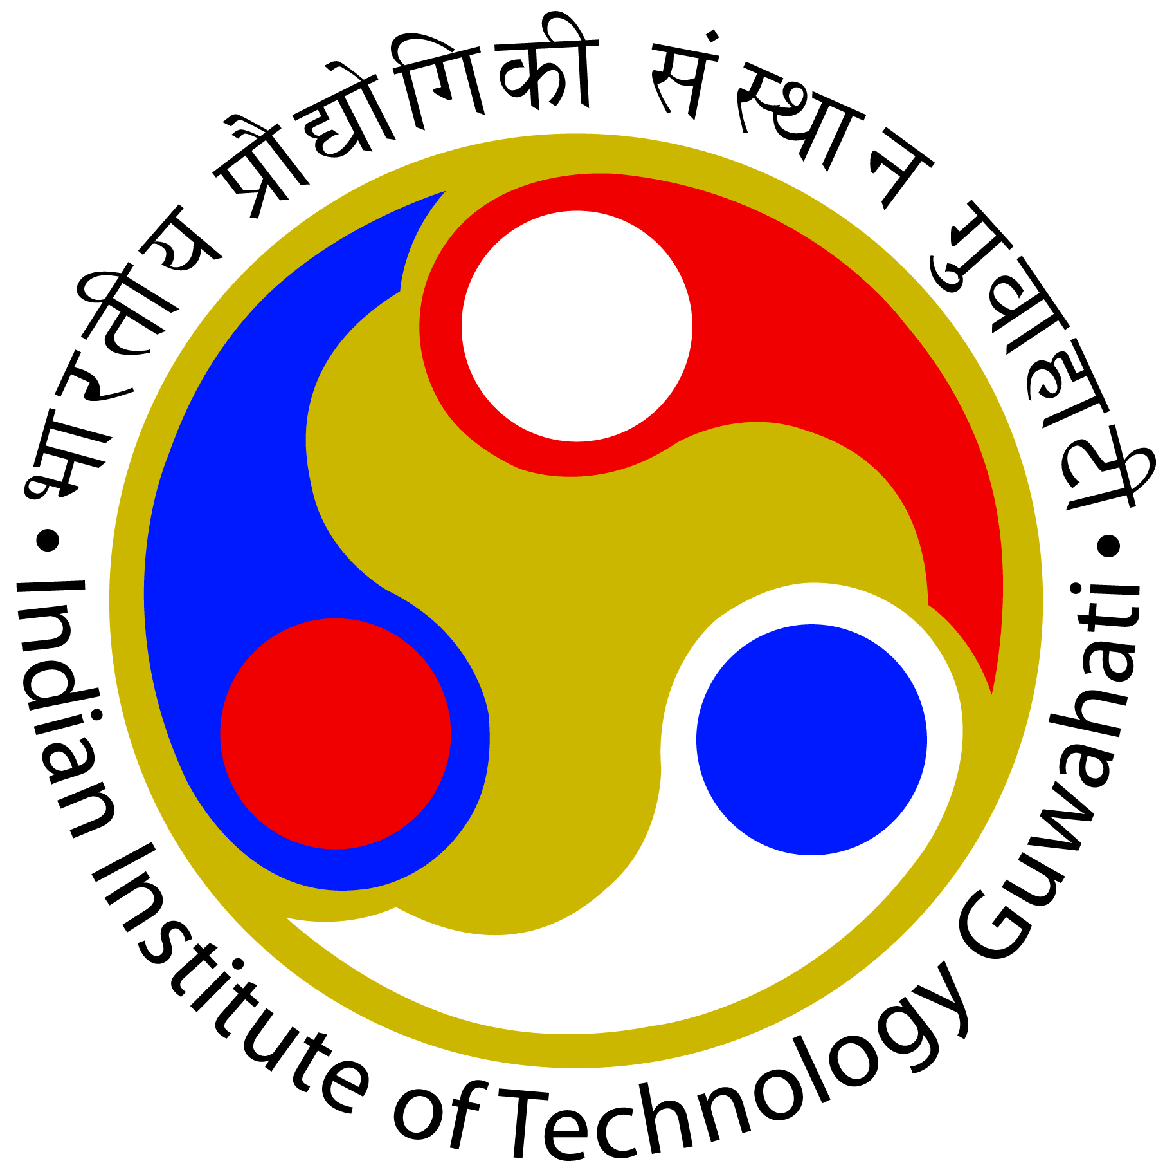

Workshop on Pedagogy Training for Teaching and Research Excellence
Under the aegis of SERB-INEA Collaboration Initiative in Engineering
(Outreach Programs for NE, J&K and Ladakh), March 15-16, 2024
Organised by Department of Computer Science & Engineering, IIT Guwahati

NO OBJECTION CERTIFICATE

Dr./Mr./Ms. ................................................................................. is a research scholar/post-doctoral fellow in ………………………………………………………………………. (center/department/school name)
under my supervision since ................................ . He/she is interested to attend the 2-day Workshop on Pedagogy Training for Teaching and Research Excellence funded under the aegis of SERB-INEA Collaboration Initiative in Engineering, scheduled from 15.03.2024 to 16.03.2024 at CSE department IIT Guwahati. I understand that this program is useful for scholars who are interested in considering teaching as a career choice. As his/her supervisor I do not have any objection in he/she attending the program. If selected, he/she will be permitted to attend the program in full from 15.03.2024 to 16.03.2024 at CSE department, IIT Guwahati.

Date:

Signature of Supervisor:
Name:
Designation:
Department/Center/School:

