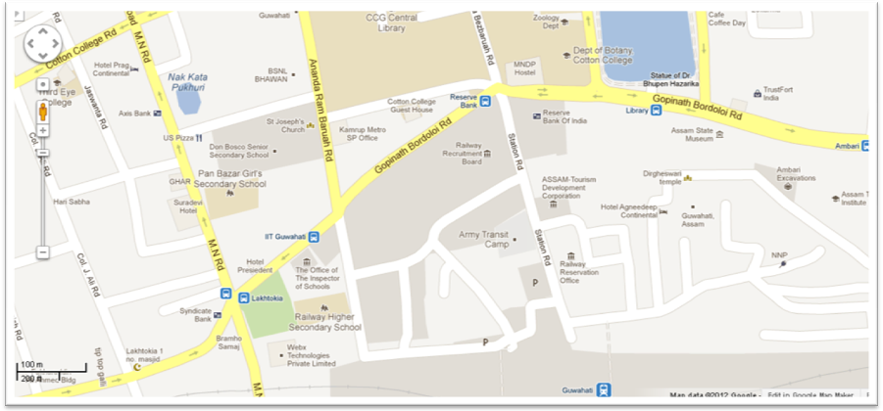
A limited number of IIT buses run regularly from Guwahati city-Lakhtokia (Near to Hotel President, which is about 0.5 km from the Guwahati Railway Station) to IIT Campus.
↑
Guwahati Railway Station
(Exit through Platform-1 /Panbazar side)
Direction from Railway Station to Lakhtokia:
- From Guwahati Railway Station, Exit through Platform-1 side (Panbazar side) Exit Gate.  - Walk along the Straight Road (Station Road), You can see Army Transit Camp on your left hand side and Railway Reservation Centre on right hand side.  - Walk further, till you see the Reserve Bank of India Building on your right hand side.  - Take left turn in Gopi Nath Bordoloi (GNB) Road to proceed in the direction of Hotel President/ Lakhtokia.  - Take a right run in the Ananda Ram Baruah Road – Locate St.Joseph’s Church / Don Bosco School’s Church.  - On the Road, try to locate the Green Valley - IIT Bus bearing the name plate “IIT” and board the IIT Bus.  From: Guwahati City (Don Bosco School’s Church) To: IIT Campus  Bus Timings:  Regular Days: 6:45 am, 8:15 am, 10 am, 12 noon, 1 pm, 2 pm, 3 pm, 4 pm, 5:15 pm, 6:45 pm, 7:30 pm, 8 pm, 8:30 pm, 8:55 pm  Saturday/Sunday: 6:45 am, 7:45 am, 8:15 am, 10 am, 11 am, 1 pm, 2 pm, 3 pm, 4 pm, 5 pm, 6 pm, 7:15 pm, 8 pm, 8:30 pm, 8:55 pm | 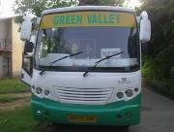
Autos and Taxis are also available at the Guwahati Railway Station.

Note: In the map, IIT Guwahati Bus stop is marked in Blue color which is old one. Now IIT Bus is stopped near to St. Joseph’s Church (Don Bosco School’s Church) in Ananda Ram Baruah Road.

