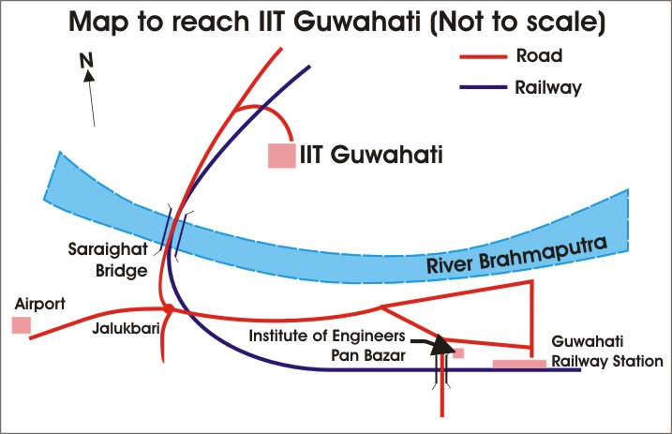
How to reach IIT Guwahati campus from Guwahati Airport?
- In the Arrival Lounge (inside Airport), there is a prepaid taxi counter. You can book and take a prepaid taxi to IIT Guwahati. The taxi fare is: Rs.550 approximately.
- You can call Prime Cabs: Phone number is: 0361- 2222233. They also charge Rs.500/- + Rs.50/- from Airport to IIT Campus
- You can call My Taxi: Phone number is: 0361- 2228888

How to reach IIT Guwahati campus from Guwahati Railway Station?
From Railway platform, Exit through First platform Gate – Panbazar side.
Better option would be: Taking call/radio taxi
- Prime Cabs: Phone number is: 0361- 2222233 (Tata Indigo, Tata Indica, etc)
- My Taxi: Phone number is: 0361- 2228888 (Tata Indigo, Tata Indica, etc)
- Green Cab: Phone number is: 0361-7151515 (Tata NANO – Small Car)

Alternative way, if you are able to spot the Green Valley bus of IIT Guwahati near Don Bosco School’s Church at Panbazar (walkable distance):
- A limited number of the Institute buses (hired from Green Valley Travels – Look for a board written On IIT Duty or IIT in the front) run regularly from Guwahati city – Panbazar (Don Bosco School’s Church – St. Joseph’s Church at Panbazar), which is about half-a-kilometer from the Guwahati Railway Station) to IIT Campus.
From: Guwahati City To: IIT Campus (On Saturday and Sunday)
Timings: 6:45 am, 7:45 am, 8:15 am, 10 am, 11 am, 1 pm, 2 pm, 3 pm, 4 pm, 5 pm, 6 pm, 7:15 pm, 8 pm, 8:30 pm, 8:55 pm (Some time due to traffic jam, they may not reach the spot at right time and hence may have delayed start)
See next page for more details.
While entering the campus, the driver needs to make an entry at the entry Gate. The security may ask which area of the campus you will be going. Please tell him that you will be going to Guest House. Ask the Security Guard for the direction to the Guest House and instruct the driver to take you to the Guest House.
Note: There may be always unpredictable traffic congestion starting from Jalukbari, Saraighat Bridge (on Brahmaputra River) on NH31, and upto Agyathuri due to road construction. There is no other way to avoid this.

