Six to Eight-Page Manuscript Guideline for the 8th Asian Conference on Mechanics of Functional Materials and Structures (Title of the manuscript)

First Author¹, Second Author2 and Third Author3

^{1,}Affiliation Department Address, Institute, COUNTRY. (E-mail: abc@def.ac.in) ^{2,}Affiliation Department Address, Institute, COUNTRY.(E-mail: abc@def.ac.in) ^{3,}Affiliation Department Address, Institute, COUNTRY.(E-mail: abc@def.ac.in)

Abstract
This sample article provides information and instructions for preparing in a standard format for preparing Book Chapter of the Seventh Asian Conference on Mechanics of Functional Materials and Structures. It illustrates the paper layout, and describes points you should notice before you prepare your paper. In order to enable the publisher to bring the article into a uniform layout and style, authors are kindly requested to follow the instructions given below.

Keywords: keywords list, manuscript format

1 Title of section (e.g. General Introduction)
Each six to eight-page paper must be typed in single column format in A4 size (210 mm 297 mm) paper. The paper should be prepared with an electronic text processing system. We strongly recommend the use of Microsoft Word processing system.
The full manuscript should be submitted to acmfms2022@iitg.ac.in or the link provided at the webpage (MS-Word and PDF formats) by deadline November 30, 2022. We will print the book chapter as Lecture Notes in Mechanical Engineering (Select Proceeding of ACMFMS-2022) published by Springer.
2 Preparation of the camera-ready paper
The paper should be typed using 11pt size Times New Roman letter with single spacing between text lines. The upper and lower margin should be 25 mm, the left and right ones 20 mm.
New paragraphs are to be indented 6.3 mm from the left-hand margin, with no extra space between paragraphs.
2.1 Front matter
    - Title, affiliation(s), abstract and keywords
The first line of the title is located 2 lines (24pt) from the top of the printing box. This space is reserved for Editorial Heading.
The title of the paper should be written centered, single-spaced, in 14pt size bold capital letters. The title must not exceed three lines. The author's name should include first and middle (if any) name initial, and surname. It should be written centered, in 12pt size bold face letter, one line (12pt) below the title.
The author's affiliation should be written centered, in 11pt size italic letter with one line (12pt) space below the list of authors. The e-mail address of the corresponding author should appear after the author affiliations.
Following the authors' names and affiliations, put the abstract in not more than 150 words. Set up an additional 10 mm left and right margins. The abstract should be written in 10pt size letter with one line (12pt) space below the corresponding author's e-mail.
A 12pt space should separate the keywords line from the abstract. The keyword line should be written left aligned to the margin of the abstract and must begin with the words ‘Keywords:’ written in the normal 10pt size bold letter. Keywords should be written in 10pt size, italic letter (see above). Please, write no more than five keywords.
2.2 Diagrams, tables and figures
Care should be taken over the preparation of diagrams, tables and figures. Tables must be set as part of the text. All tables must have a caption centered over the table and should be numbered sequentially and start with ‘Table x:’ (x stands for a number).
Figures will either be entered in one column of a maximum size of 170 mm wide respectively. A minimum line width of 1pt is required at actual size. Annotations should be in 10pt with the first letter only capitalized. All figures should be numbered sequentially and captioned. The caption should be written centered below the figure and start with ‘Figure x:’ (x stands for a number). Figures should be embedded in the document. Please leave an extra space of 10pt before and after each table and figure.

Example of Table 1:

Table 1: Material properties (As per manufacturer)
Material | Melting point (℃) | Density (kg/m³)
Copper (Cu) | 1083.4 | 8940
Aluminum (Al) | 660 | 2700
Silicon Carbide (SiC) | 2700 | 3220
Polyvinyl Alcohol | 200 | 1190
Zinc Stearate | 125 | 1095
Magnesium (Mg) | 648 | 1740

Example of Fig. 1:

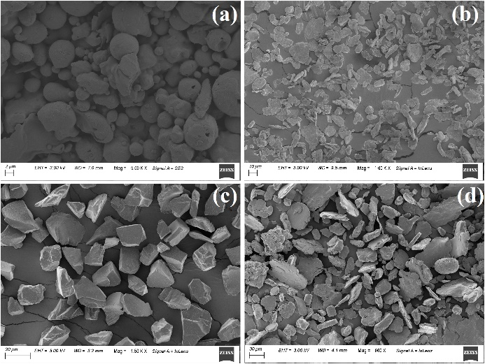

Figure 1: FESEM Image of Powder

Diagrams or figures should be located within the paper. The figures should have a resolution of at least 300 dpi.
2.3 Equations
Equations should be prepared in Word with the appropriate equation editor. Each equation should occur on a new line with uniform spacing (11pt) from adjacent text as indicated in this template. The equations, where they are referred to in the text, should be numbered sequentially and their identifier enclosed in parenthesis, right justified as indicated below. The punctuation should be used in equations as they were regular sentences. Example:... some text

$E=mc^{2}$. | (1)

Please pay attention that all variable references in text must be written the same style as in displayed equations.
The citation of figure(s), reference(s) and equation(s) have to be abbreviated as Fig. x; Ref. [x]; Eq. (x) or, in plural form, as Figs. x,y; Refs. [x,y]; Eqs. (x,y) - where x, y stand for a number. Above phrases are typed in full word when they appear as the first word of sentence. Citation of table(s) is always written in full word - Table x or Tables x, y. Please be consistent in the use of capital letters, abbreviations and punctuation.
2.4 Units
Please use SI – units throughout the paper.

3 General style preferences
3.1 Style of writing
Papers are accepted on the basis that they match high international standards of scientific writing. The author himself is responsible for the correctness of the scientific content.
Abbreviations should be spelt out in full the first time they appear and their abbreviated form included in brackets immediately after. Do not use more than three level depth of headings.
3.2 Paper length
The paper, including the title page, figures, and tables should be 6 to 8 pages.
Acknowledgments
These and the Reference headings are in bold but have no numbers. Text below continues as normal.
4 References
The papers in the reference list must be cited in the text. In the text the citation should appear in square brackets “[]”, as in, for example, ‘…In Ref. [2] an investigation of the stability and chaos for wheel suspension was presented....” In the Reference list the font size should 10pt. The author’s names should be terminated by a ‘full stop’. The citation number should be enclosed in brackets.
The book titles should be in italics, followed by a ‘full stop’. Proceedings or journal titles should be in italics. For instance:
References
- S. Miyagi, M. Iwate and A. Aomori, Title of the Paper, Title of the Jouneral 20 (2020) 7342-7344.
- A. Author, Title of the Book, Publisher, City, 2020.
- B. Author, Title of the paper, Title of the Proceedings, Name of Editor, 2020, pp. 7342-7344.
- A. Bishop et al., A functionally gradient material produced by a powder metallurgical process, Journal of materials science letters 12 19 (1993) 1516-1518.
- T. Prasad Yadav, R. Manohar Yadav, and D. Pratap Singh, Mechanical milling: a top down approach for the synthesis of nanomaterials and nanocomposites, Nanoscience and Nanotechnology 2 3 (2012) 22-48.
- F. Erdemir, A. Canakci and T. Varol, Microstructural characterization and mechanical properties of functionally graded Al2024/SiC composites prepared by powder metallurgy techniques, Trans Nonferrous Met Soc 25 (2015) 3569-3577.
5 Sending your paper
Please submit a source version of your paper formatted according to the template in MS-Word processing system. The paper should be submitted to acmfms2022@iitg.ac.in.
6 Submission dates
The final date for the receipt of the electronic files of the papers is November 30, 2022.

