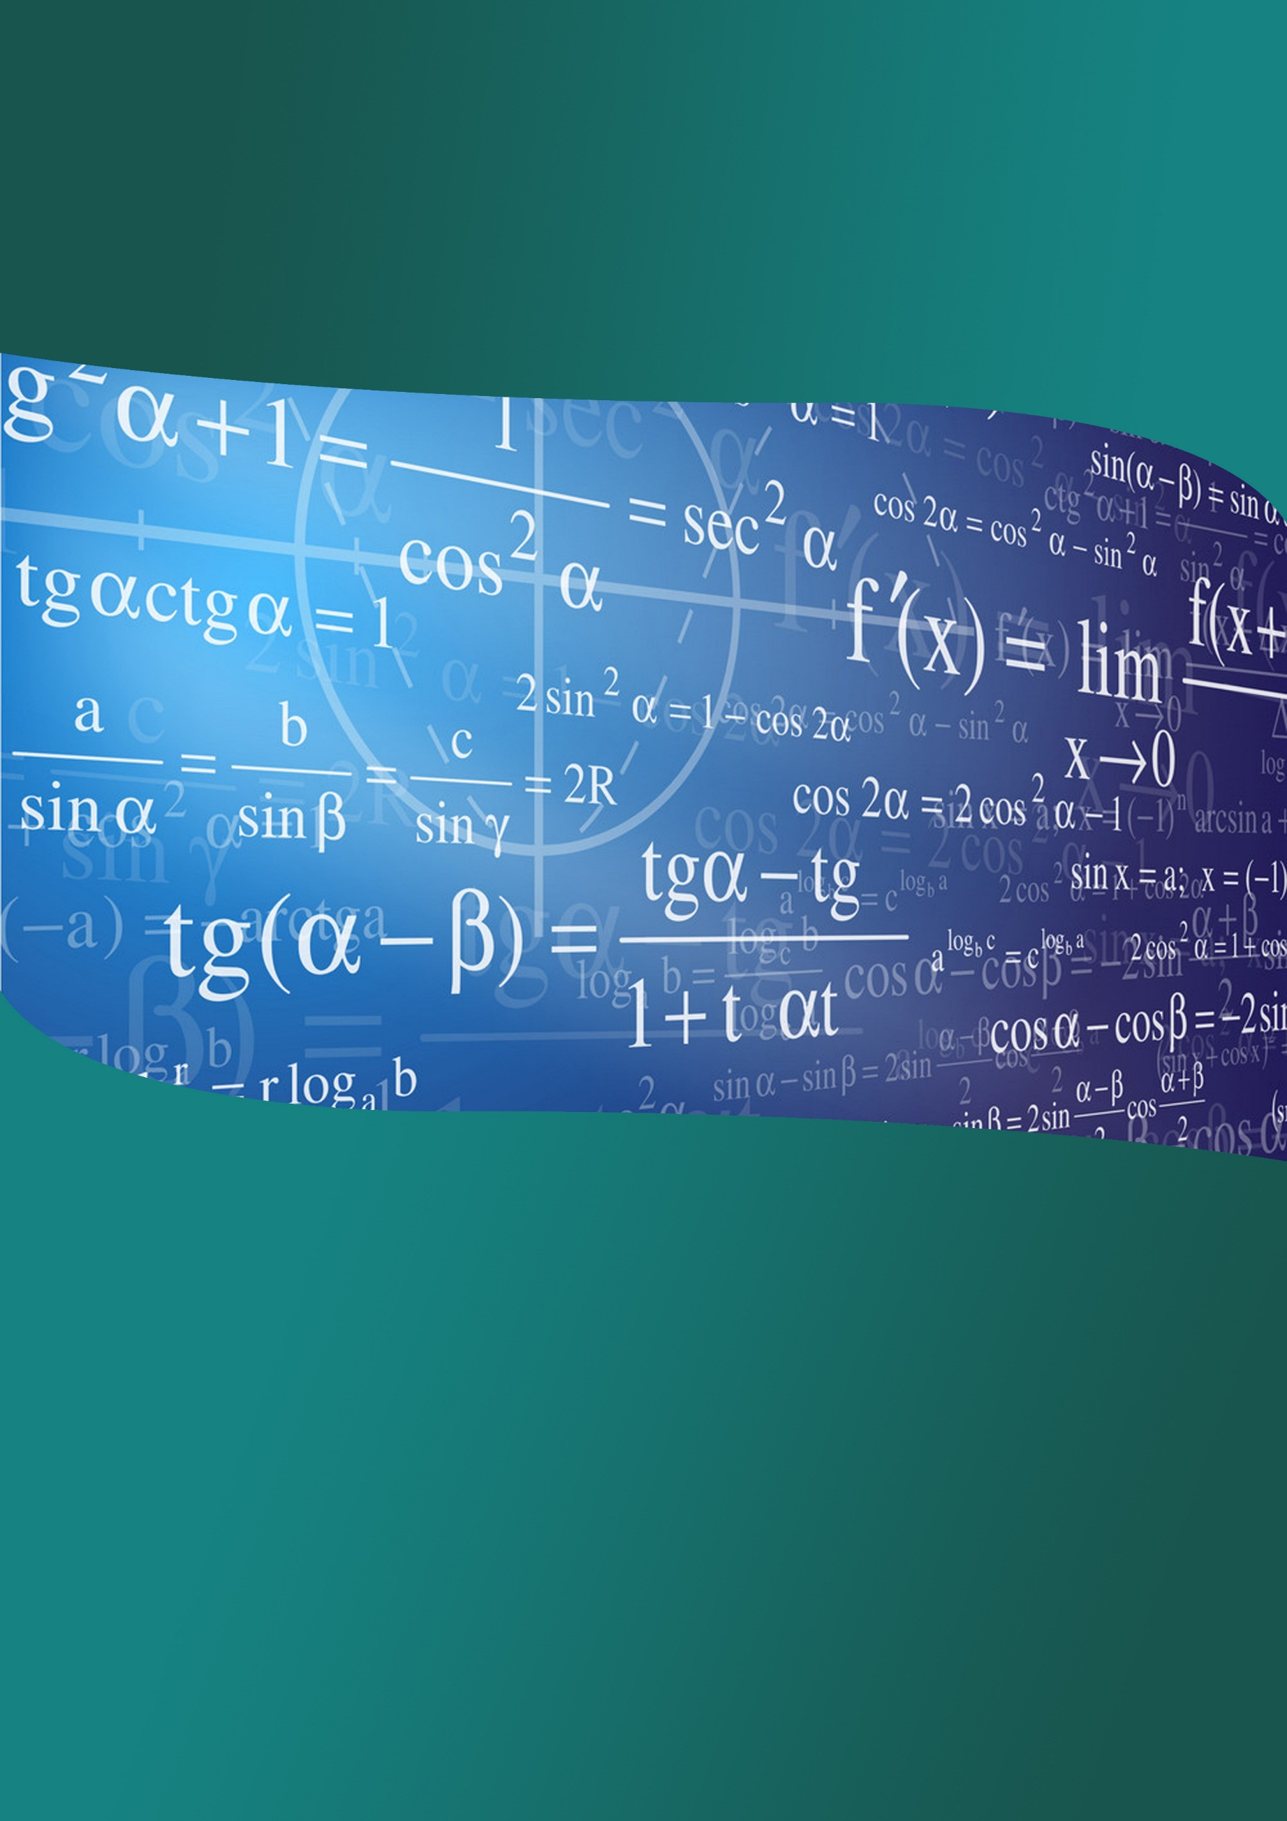
Indian Institute of Technology Guwahati

Mathematics Training Programme for
Undergraduate Students

July 01 -13, 2019

Conducted by:
Department of Mathematics, IIT Guwahati

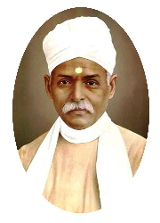
Organized by:
Center of Excellence in Science and Mathematics Education, under
Pandit Madan Mohan Malaviya National Mission on Teachers and Teaching
URL: http://www.iitg.ac.in/cet/pmmmnmtt.html

Announcement
Mathematics Training Programme for Undergraduate Students
The Center of Excellence in Science and Mathematics Education, under Pandit Madan Mohan Malaviya National Mission on Teachers and Teaching, IIT Guwahati is organizing a two-week programme titled Mathematics Training Programme for Undergraduate Students during July 01 – 13, 2019.
This workshop will be devoted to courses on Real Analysis, Linear Algebra, Modern Algebra and Differential Equations. Each course will consist of lectures as well as practical sessions and will cover important topics which are taught undergraduate honours course in Mathematics.
The participants will be first and second year undergraduate students pursuing honours course in Mathematics. Those first and second year students among the top twenty students of Assam region in the Madhava Mathematics Competition (a national level competition) held on 6 January 2019 will be invited to participate. The rest of the participants (with a total intake of 35) will be selected from various colleges and institutions of the North East region on the basis of recommendations by the colleges.
Local hospitality including accommodation, food, etc. be provided and travel by 2nd AC train or by bus will be reimbursed to all outstation participants attending the course.
How to apply?
Interested students are requested to hand over the Recommendation Form to a teacher of his/her Department. Teachers are requested to nominate up to three students and put the order of preference according to their ability to understand and motivation, not necessarily by their marks in the exam. The completed form may be sent by the teacher to the following address:
Head, Department of Mathematics
IIT Guwahati, Guwahati 781039
Assam
Alternately a scanned copy of the completed application form can be sent to the email to pmmmnmtt.iitg@gmail.com with a copy to mathoff@iitg.ac.in
Important Date:
Last date for applying for participation: 15 June, 2019.

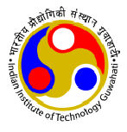
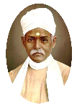
Mathematics Training Programme for Undergraduate Students
01 – 13 July, 2019
Center for Excellence in Science & Mathematics Education, PMMMNMTT
Indian Institute of Technology Guwahati

Recommendation Form

Name of the College: _____________________________________________________________________________________
Address:_______________________________________________________________________________________________
Name of the Teacher: ______________________________Mob: ___________________ Email:__________________________
Sr. No. | Full Name | Semester (II/IV) | Order of Preference | Phone No. | Email

______________________________ ___________________________
Signature of the Teacher Signature of HoD/Principal
Date: ____________________ Seal Date: ____________________
Please nominate up to three students and put the order of preference according to their ability to understand and motivation, not necessarily by their marks in the exam. The completed form may be sent to Head, Department of Mathematics, IIT Guwahati, Guwahati 781039, Assam, so as to reach by 15 June, 2019. Alternately, the scanned copy may be sent by email to pmmmnmtt.iitg@gmail.com with a copy to mathoff@iitg.ac.in.

