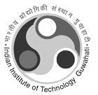 | Indian Institute of Technology Guwahati
 | FORM: 6(A) | CREDIT WAIVER COMPREHENSIVE EXAMINATION COMMITTEE
ACADEMIC DIVISION

EXAMINATION COMMITTEE
Sl. No. | Name | Designation | Department | Signature
1 |  | Convener
2 |  | Member
3 |  | Member
4 |  | Member
5
6
7

Chairman, DPPC |  | ADoAR/DoAR

